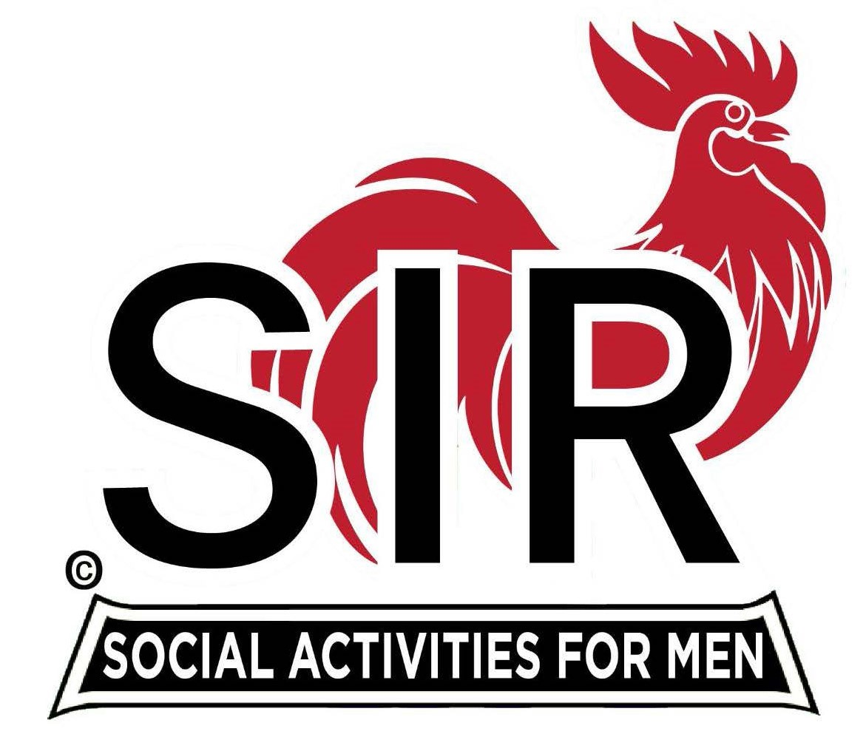
Las Trampas Branch 116
BEC Meeting Agenda
September 18, 2023, 9:15 AM at Boundary Oak
The Mission of SIR is to enhance the lives of our members through fun activities, events and luncheons while making friends for life.

9:15 am Call to order; Secretary, Paul Ramacciotti – Confirm quorum and
Approval of August 21, 2023 BEC meeting minutes

9:20 am Standing Reports

- Treasurer – Jeff Johnson, Charlie Guthrie

- Subsidy
- Lunch Cost
- Dues
- Free Lunch - January

- Luncheon Report – Mike Schneider

- September 18 Boundary Estimated Count

- Membership – Phil Goff

4. RAMP Department Head Reports:

- Recruitment – Don Schroeder
- Activity Coordinator – Mike Ward
- Member Relations - Michael Barrington
- Publicity – Paul Russell

9:40 am Little SIR Updates – Alan Pope

- Speaker Info – John Mercurio, East Bay Parks Director
- Birthday Boys – September

9:50 am Updates & New Business

- Farmer’s Market Update
- Holiday Party – Participation
- 2024 Luncheons

10:15 am Adjourn: Lunch Preparations

